Dominic Drury

09/23/2024

CS-470

4-3 Assignment: Lambda and Gateway API

First serverless compute function

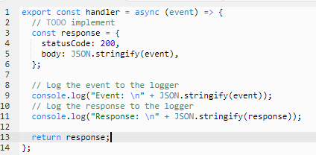

Execution results

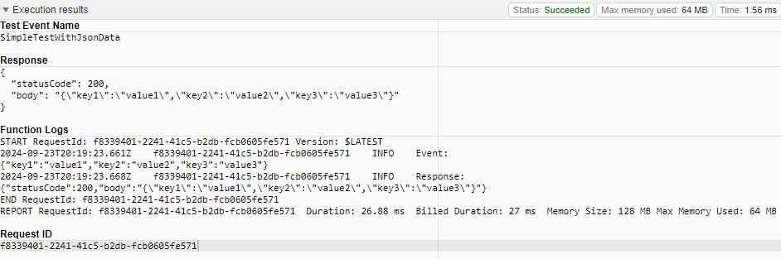Screenshot or JSON for the created test event “EchoWithQuery”

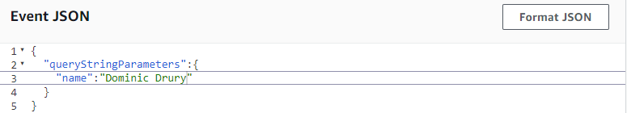

Source code or screenshot for index.js (about 22 lines of code)

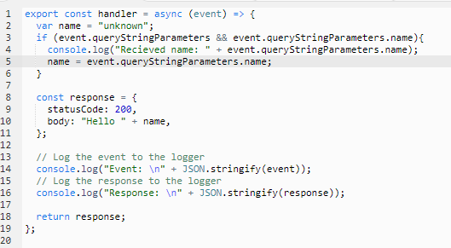

EchoWithQuery execution results

